Product Inventory Management System

Backend Project Documentation

TEAM LEADER: SWETHA.V
TEAM MEMBER: GOPIKA.M
TEAM MEMBER: SUJATHA.N
TEAM MEMBER: POOJA.K
TEAM MEMBER: DIVYA.R
Year: 2026

PROJECT OVERVIEW
The Product Inventory Management System is a backend-focused web application developed using Node.js, Express.js, and MongoDB, designed to provide a secure and scalable solution for managing product data through RESTful APIs. The system enables users to create accounts, log in securely, and access protected routes using JWT-based authentication, ensuring that only authorized users can perform operations. It supports complete CRUD functionality, allowing users to add new products, view their inventory, update product details such as price or quantity, and delete items when needed.

1. Introduction

The Product Inventory Management System is a backend web application developed to manage product data efficiently. This project is created using Node.js, Express.js, and MongoDB Atlas.

The main purpose of this system is to help users store, update, and manage product information in a database. The system provides authentication so that only authorized users can access the product data. Each user can manage their own products securely.

This project demonstrates how backend technologies work together to build a secure and scalable API-based application.

2. Objectives

The main objectives of this project are:

- To develop a backend application for managing product inventory.
- To implement secure user authentication using JWT.
- To allow users to perform CRUD operations on products.
- To store and manage product data using MongoDB database.
- To create RESTful APIs using Express.js.

3. Technologies Used

Node.js

Node.js is a JavaScript runtime environment used to build server-side applications. It allows developers to run JavaScript outside the browser.

Express.js

Express.js is a web framework for Node.js used to build APIs and handle HTTP requests.

MongoDB

MongoDB Atlas is a cloud-based NoSQL database used to store product and user data.

Visual Studio Code

Visual Studio Code is used as the development environment for writing and managing the project code.

Other Packages

Mongoose – Connects Node.js with MongoDB.

JWT (JSON Web Token) – Used for authentication.

bcryptjs – Used for password encryption.

dotenv – Manages environment variables.

4. System Architecture

The project follows a simple backend architecture where the user interacts with the server through APIs.

The working process is:

User → API Request → Express Server → MongoDB Database → Response

- The user sends a request to the API.

- The Express server processes the request.

- Authentication middleware checks the user token.

- The controller performs the required operation.

- MongoDB stores or retrieves the data.

- The server sends a response back to the user.

5. Features of the System

1. User Authentication

The system allows users to register and login securely using JWT authentication.

2. Product Management

Users can manage product inventory by performing CRUD operations.

3. Secure Data Access

Each user can only access their own products.

4. Product Search

Users can search for products by name.

5. API Security

Middleware is used to protect the APIs and verify authentication tokens.

6. Database Design

The system uses two collections in MongoDB.

- Users Collection

- Stores user information.

Fields include:

id
name
email
password
timestamps

Products Collection
Stores product information.

Fields include:

id
userId
name
price
quantity
description
timestamps

Relationship:
One user can have multiple products.

7. User Flow of the System

The user flow describes how a user interacts with the Product Inventory Management System from registration to product management.

Step 1: User Registration
A new user registers in the system by providing basic details such as name, email, and password. The system stores this information securely in the database.
Step 2: User Login
After registration, the user logs into the system using their email and password. If the credentials are valid, the system generates a JWT token for secure authentication.

Step 3: Authentication Verification
The JWT token is sent in the request header for accessing protected routes. The authentication middleware verifies the token before allowing access to the APIs.

Step 4: Product Management
Once authenticated, the user can perform different operations on products such as:
Add new products
View existing products
Update product details
Delete products from the inventory

Step 5: Data Storage
All product and user information is stored in the MongoDB Atlas database, which allows efficient storage and retrieval of data.
Step 6: API Response
After performing the requested operation, the server sends a response back to the user through the API.

8. Folder Structure

The project follows a modular folder structure:

server
├── src
│ ├── controllers
│ ├── models
│ ├── routes
│ ├── middlewares
│ ├── db
│ └── server.js
├── .env
├── package.json

This structure helps keep the project organized and maintainable.

9. API Testing

The APIs can be tested using Thunder Client extension in Visual Studio Code.

Main APIs tested include:

Register User
Login User
Create Product
Get Products
Update Product
Delete Product

These APIs allow users to manage products securely.

10.Scope of the Project

The scope of the Product Inventory Management System includes maintaining product data such as product name, quantity, and other related information.
The system helps store managers easily manage inventory records.
The application can be extended in the future to support advanced features such as barcode scanning, product search filters, user authentication, and database integration. It can also be integrated with billing systems to
automatically update stock after each sale.
This project provides a basic foundation for inventory management systems used in small and medium-sized businesses.

11.Screenshots and Demo video link

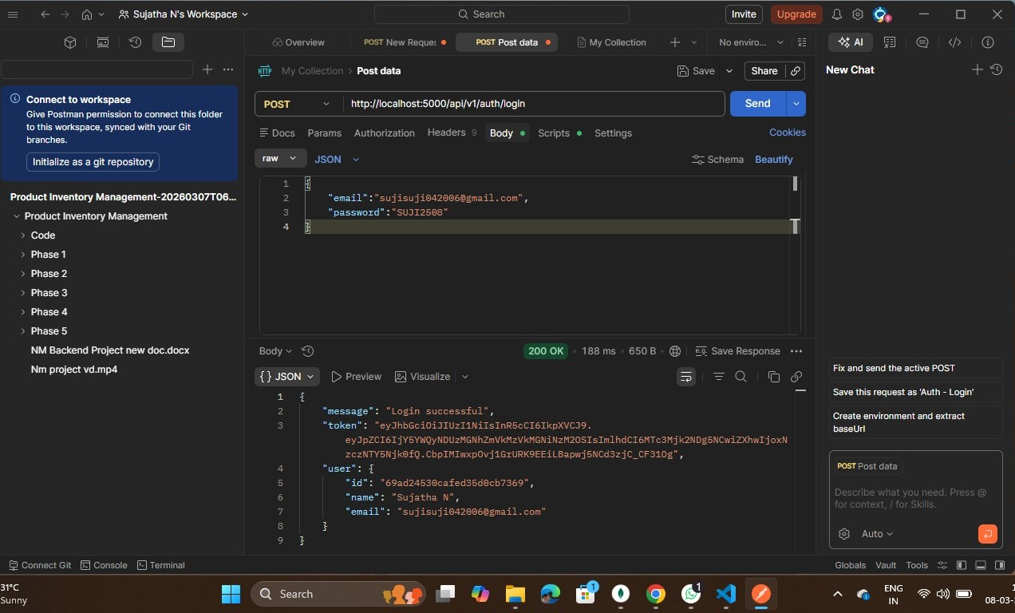

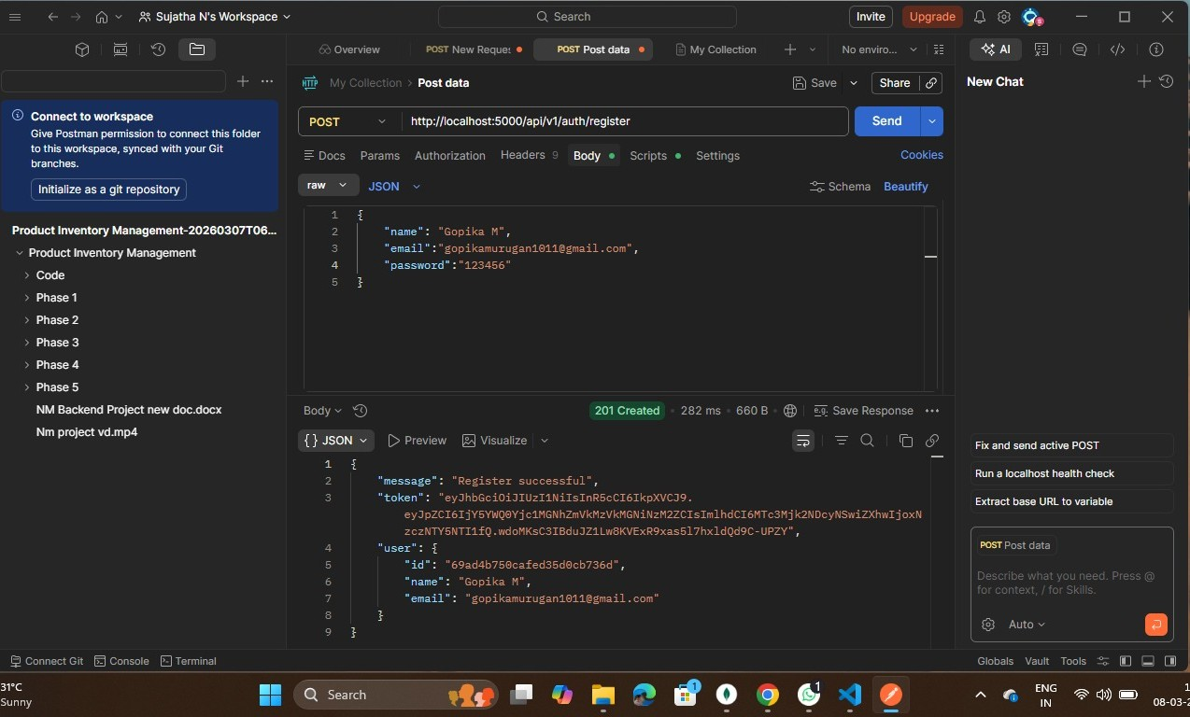

Demo Video:

https://drive.google.com/file/d/17r2W-mvBRYQkyCEH8YF824mWZJvlYftc/view?usp=drivesdk

12. Future Enhancements

The system can be improved in the future by adding more features such as:

- Frontend interface using React.

- Product image upload functionality.

- Dashboard for analytics.

- Role-based access control for admin users.

13. Conclusion

The Product Inventory Management System successfully demonstrates the development of a backend application using Node.js, Express.js, and MongoDB. The system provides secure authentication and efficient product management through RESTful APIs.

This project helped in understanding backend development concepts such as API creation, database integration, authentication, and middleware usage.

